Introduction
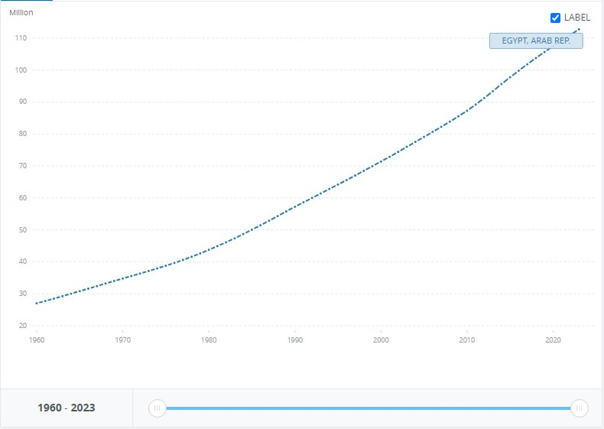
Population growth is a threatening problem that faces Egypt which has a population of 106,890,565. As illustrated in Figure (1), the population in Egypt went from 27M to 112M in 63 years with a 314% increase in population and 2% growth a year, the Greater Cairo Metropolitan Area (GCMA) which has fifth of Egypt’s population is expected to further increase to 24 million by 2027, with Birth numbers exceeding deaths which makes Egypt more and more crowded than ever in each minute passing, as a direct result, more people are using up the same resources, space, and public sectors. So, population growth in this area can cause urban congestion which leads to severe problems, most severe of which is connectivity, the problem to be solved.
Fig. 1 Rate of Egypt's population growth
After research, a multitude of solutions already tried were found, two of which are Tower Bridge and Hawthorne Bridge. Tower Bridge is an important bascule bridge in London, one of its strengths is its transportation importance as it can carry 40,000 people and 21,000 vehicles. The bridge's bascules are lifted around 800-1,000 times per year to allow the passage of tall ships and river vessels. While on the other hand one of its weaknesses is sensitivity to vibrations as when the bridge bascules open, they're subject to vibrations and oscillations. Over time, this can cause wear and tear, necessitating frequent maintenance. The other solution already tried is Hawthorne Bridge, one of the busiest bridges in Portland is a vertical lift bridge in Portland, USA. One of its strengths is its transportation importance as it serves as a route between downtown Portland and the South Waterfront. One of its downsides is limited vertical clearance due to its vertical lift mechanism.

The dimensions of the prototype are as follows: the scale is 1:50. The total length of the bridge is 100cm. The bridge has two lanes of traffic, and the width of the traffic lane is 7 cm. It also has two lanes for pedestrians with a width of 3cm. An island of 2cm exists in the middle width of the bridge. The clearance between the water level and the lowest point of the deck of the bridge is 10 cm. The bridge should allow the passage of ships that need a minimum width of 24cm, a maximum width of 28cm and a minimum height of 20cm. The bridge should be able to carry a traffic load of a minimum 10 kg mass at the midpoint of the bridge of the largest fixed span. The maximum deflection at the same point doesn’t exceed 5 cm without collapse. The maximum weight of the prototype shouldn’t be more than 20 kg. By these dimensions, the bridge will meet the design requirements.

.

